A Technical Seminar
on

NEURAL NETWORKS

Bachelor of Technology
in
Computer Science and Engineering,
2024-2025

Submitted by
HIMANSHU BIJJA
23311A05P5

Technical Seminar Coordinator
Dr. Sreedhar Bhukya
Professor & Associate Dean(R&D)



Department of Computer Science and Engineering
SREENIDHI INSTITUTE OF SCIENCE AND TECHNOLOGY (AUTONOMOUS)
Yamnampet (V), Ghatkesar (M), Hyderabad – 501301, T.S.



DEPARTMENT OF COMPUTER SCIENCE AND ENGINEERING
SREENIDHI INSTITUTE OF SCIENCE AND TECHNOLOGY
(AUTONOMOUS)
Yamnampet (V), Ghatkesar (M), Hyderabad – 501301, T.S.

B.Tech II Year II Semester
CSE - D
Technical Seminar (9E484)
A.Y. 2024-25

Title of the Seminar: NEURAL NETWORKS

Roll Number : 23311A05P5
Name of the Student: HIMANSHU BIJJA
Date of Seminar: 02-06-2025
______________________________________________________

Department of Computer Science and Engineering

Sreenidhi Institute of Science and Technology



CERTIFICATE
This is to certify that this Technical Seminar report on “Neural Networks”, submitted by Himanshu Bijja (23311A05P5) in the Academic year 2024-25 in the partial fulfilment of the academic requirements of Jawaharlal Nehru Technological University for the award of the degree of Bachelor of Technology in Computer Science and Engineering, is a Bonafide work that has been carried out by them as a part of their Technical Seminar during Second Year Second Semester, under our guidance. This report has not been submitted to any other Institute or university for the award of any degree.

Coordinator
Dr. Sreedhar Bhukya
Professor & Associate Dean(R&D)
Department of CSE

INDEX

S. No | List of Contents | Page No.
1 | Abstract | 1
2 | Presentation Slides | 1-10
3 | Reference Paper | 11-40

ABSTRACT

GNeural networks are a class of machine learning algorithms inspired by the structure and functioning of the human brain. Designed to recognize complex patterns and relationships in data, they form the backbone of modern artificial intelligence (AI) systems. At their core, neural networks consist of interconnected nodes (or "neurons") arranged in layers that process and transmit information. Through techniques like forward propagation and backpropagation, these networks learn to make predictions or decisions based on input data.

Over time, neural networks have evolved into various specialized architectures such as Convolutional Neural Networks (CNNs) for image analysis, Recurrent Neural Networks (RNNs) for sequential data, and Generative Adversarial Networks (GANs) for data generation. Their ability to automatically extract features from raw data has revolutionized fields like computer vision, natural language processing, robotics, and healthcare.

The increasing availability of large datasets and powerful computing hardware has significantly accelerated the development and deployment of neural networks. With frameworks like TensorFlow and PyTorch, building and training deep neural networks has become more accessible to researchers and developers. As neural networks continue to grow in complexity and capability, they are expected to play an even greater role in solving real-world problems, enabling more intelligent and autonomous systems across various industries.

Presentation Slides



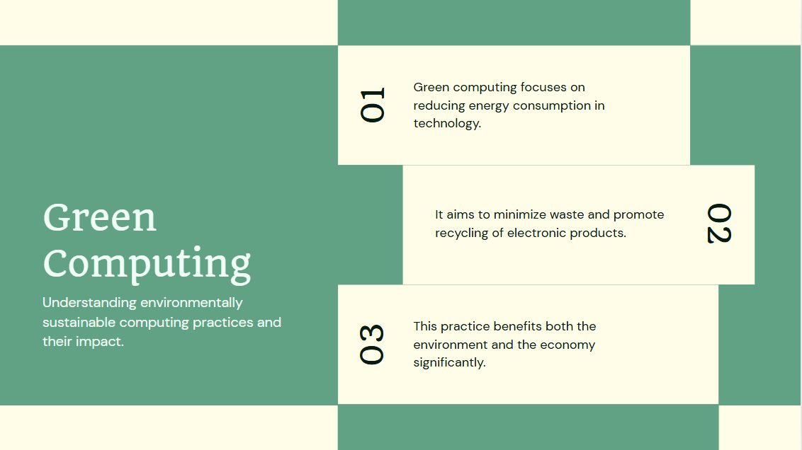

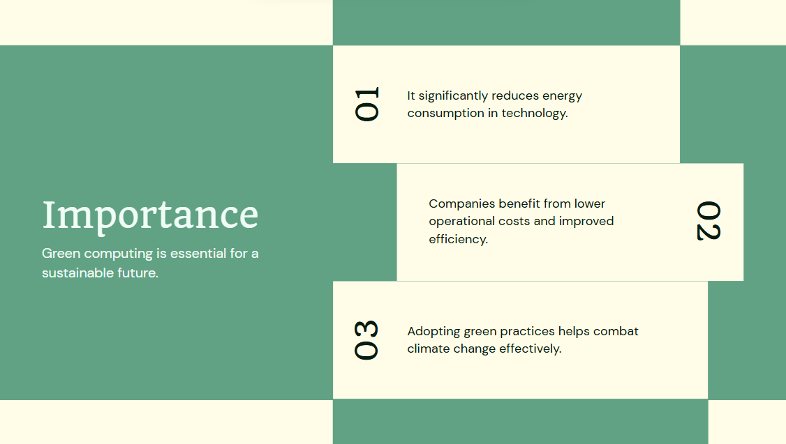








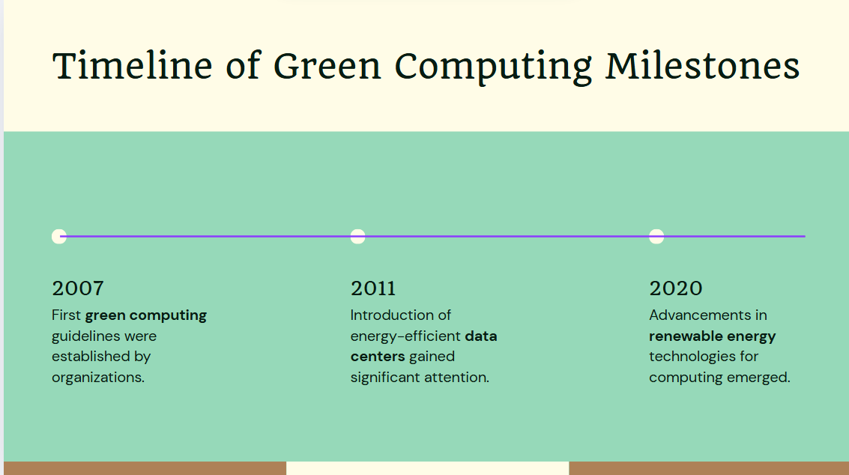

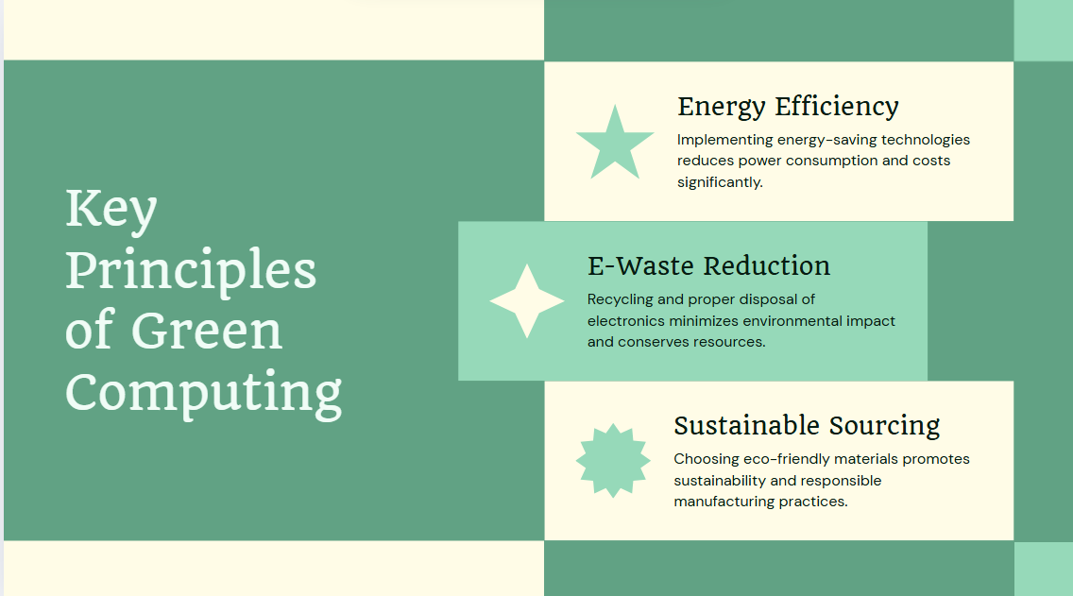



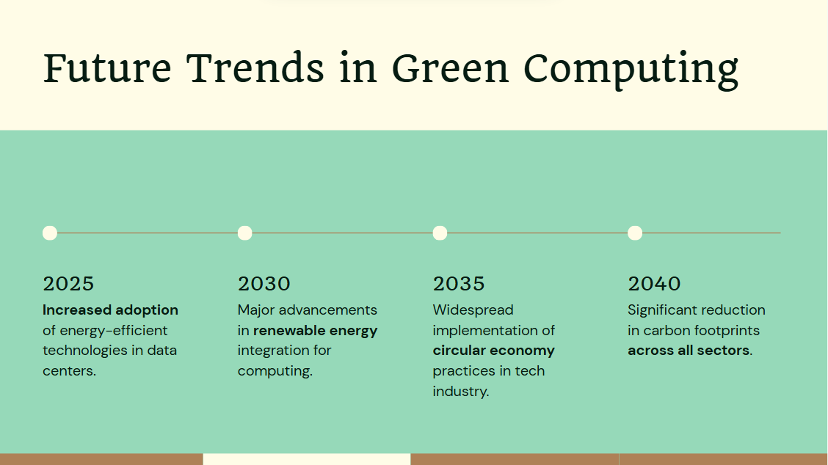

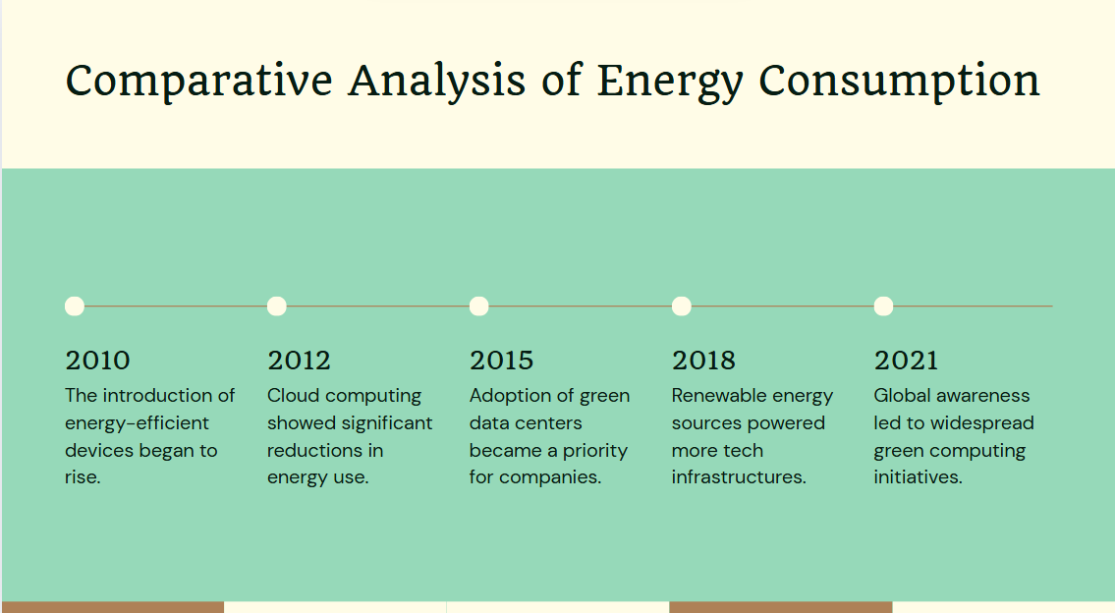



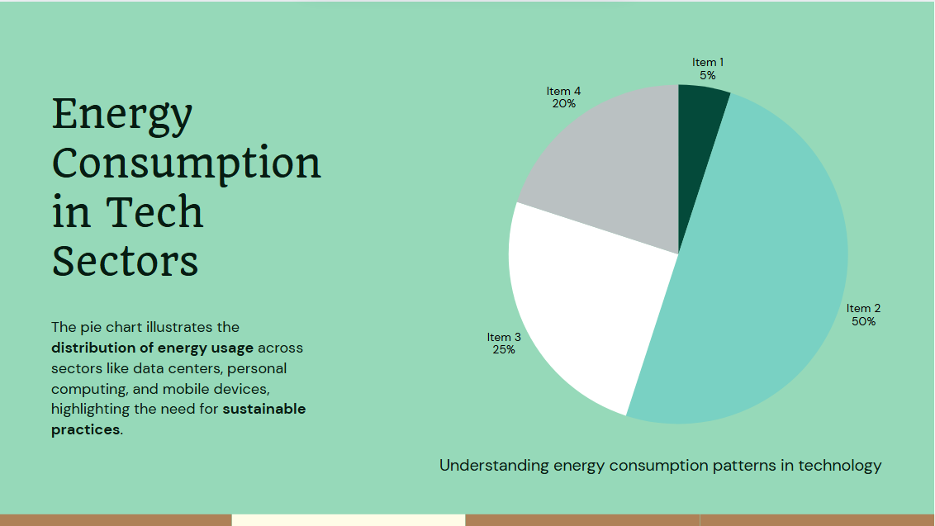





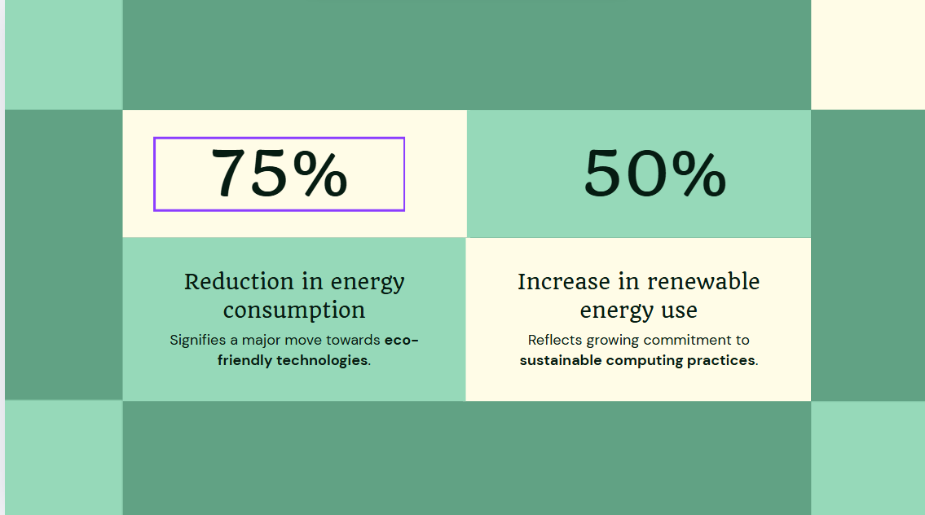



References on Neural Networks

Books
Goodfellow, I., Bengio, Y., & Courville, A. (2016). Deep Learning. MIT Press.
Available at: https://www.deeplearningbook.org/
This comprehensive textbook is considered a foundational resource in the field of deep learning. It covers the theoretical concepts, architectures, and mathematical underpinnings of neural networks, and is widely used in graduate-level courses and research.

Haykin, S. (2009). Neural Networks and Learning Machines (3rd ed.). Pearson Education.
This book offers a classical introduction to neural networks and learning algorithms, covering key topics such as perceptrons, backpropagation, and self-organizing maps. It is ideal for understanding the theoretical and engineering aspects of neural computation.

Bishop, C. M. (2006). Pattern Recognition and Machine Learning. Springer.
This book focuses on statistical approaches to machine learning, including neural networks. It is notable for its rigorous treatment of probabilistic models and is often recommended for advanced studies in machine learning and pattern recognition.

Research Papers

LeCun, Y., Bengio, Y., & Hinton, G. (2015). Deep learning. Nature, 521(7553), 436–444.
https://doi.org/10.1038/nature14539
This landmark paper provides an overview of deep learning techniques and their success in computer vision, speech recognition, and natural language processing. Written by pioneers in the field, it explains the resurgence of neural networks due to advances in data, computation, and algorithms.

Rumelhart, D. E., Hinton, G. E., & Williams, R. J. (1986). Learning representations by back-propagating errors. Nature, 323, 533–536.
This seminal work introduced the backpropagation algorithm, which is essential for training multi-layer neural networks. It marks a turning point in making neural networks practical for supervised learning tasks.

Online Resources
Stanford University. CS231n: Convolutional Neural Networks for Visual Recognition.
Available at: http://cs231n.stanford.edu/
This is a widely cited online course that provides in-depth lectures, notes, and assignments focused on computer vision using convolutional neural networks (CNNs). Developed at Stanford, it’s considered one of the best free educational resources on deep learning.
DeepLearning.ai. Neural Networks and Deep Learning Specialization.
Available at: https://www.deeplearning.ai/programs/
Created by Andrew Ng, this Coursera-based specialization introduces neural networks and deep learning concepts from the ground up. It is highly accessible to beginners and provides hands-on experience with Python and TensorFlow.
Google AI. Google AI Blog.
Available at: https://ai.googleblog.com
This official blog features updates, tutorials, and breakthroughs from Google’s AI research teams. It includes cutting-edge work in neural networks, deep learning, and scalable ML infrastructure.

Neural networks: An Overview
By: Schmidhuber

Abstract
In recent years, deep artificial neural networks (including recurrent ones) have won numerous contests in pattern recognition and machine learning. This historical survey compactly summarizes relevant work, much of it from the previous millennium. Shallow and Deep Learners are distinguished by the depth of their credit assignment paths, which are chains of possibly learnable, causal links between actions and effects. I review deep supervised learning (also recapitulating the history of backpropagation), unsupervised learning, reinforcement learning & evolutionary computation, and indirect search for short programs encoding deep and large networks.

Preface
This is the preprint of an invited Deep Learning (DL) overview. One of its goals is to assign credit to those who contributed to the present state of the art. I acknowledge the limitations of attempting to achieve this goal. The DL research community itself may be viewed as a continually evolving, deep network of scientists who have influenced each other in complex ways. Starting from recent DL results, I tried to trace back the origins of relevant ideas through the past half century and

Introduction to Deep Learning (DL) in Neural Networks (NNs)
Which modifiable components of a learning system are responsible for its success or failure? What changes to them improve performance? This has been called the fundamental credit assignment problem (Minsky, 1963). There are general credit assignment methods for universal problem solvers that are time-optimal in various theoretical senses (Section 6.8). The present survey, however, will focus on the narrower, but now commercially important, subfield of Deep Learning (DL) in Artificial Neural

Event-oriented notation for activation spreading in NNs
Throughout this paper, let denote positive integer variables assuming ranges implicit in the given contexts. Let denote positive integer constants.
An NN’s topology may change over time (e.g., Sections 5.3, 5.6.3). At any given moment, it can be described as a finite subset of units (or nodes or neurons) and a finite set of directed edges or connections between nodes. FNNs are acyclic graphs, RNNs cyclic. The first (input) layer is the set of input units, a

Depth of Credit Assignment Paths (CAPs) and of problems
To measure whether credit assignment in a given NN application is of the deep or shallow type, I introduce the concept of Credit Assignment Paths or CAPs, which are chains of possibly causal links between the events of Section 2, e.g., from input through hidden to output layers in FNNs, or through transformations over time in RNNs.
Let us first focus on SL. Consider two events and . Depending on the application, they may have a Potential Direct Causal Connection (PDCC) expressed

Dynamic programming for Supervised/Reinforcement Learning (SL/RL)
One recurring theme of DL is Dynamic Programming (DP) (Bellman, 1957), which can help to facilitate credit assignment under certain assumptions. For example, in SL NNs, backpropagation itself can be viewed as a DP-derived method (Section 5.5). In traditional RL based on strong Markovian assumptions, DP-derived methods can help to greatly reduce problem depth (Section 6.2). DP algorithms are also essential for systems that combine concepts of NNs and graphical models, such as Hidden Markov

Supervised NNs, some helped by unsupervised NNs
The main focus of current practical applications is on Supervised Learning (SL), which has dominated recent pattern recognition contests (Sections 5.17 2009: first official competitions won by RNNs, and with MPCNNs, 5.18 2010: plain backprop (+ distortions) on GPU breaks MNIST record, 5.19 2011: MPCNNs on GPU achieve superhuman vision performance, 5.20 2011: Hessian-free optimization for RNNs, 5.21 2012: first contests won on ImageNet, object detection, segmentation, 5.22 2013-: more contests

DL in FNNs and RNNs for Reinforcement Learning (RL)
So far we have focused on Deep Learning (DL) in supervised or unsupervised NNs. Such NNs learn to perceive/encode/predict/classify patterns or pattern sequences, but they do not learn to act in the more general sense of Reinforcement Learning (RL) in unknown environments (see surveys, e.g., Kaelbling et al., 1996, Sutton and Barto, 1998, Wiering and van Otterlo, 2012). Here we add a discussion of DL FNNs and RNNs for RL. It will be shorter than the discussion of FNNs and RNNs for SL and UL

Conclusion and outlook
Deep Learning (DL) in Neural Networks (NNs) is relevant for Supervised Learning (SL) (Section 5), Unsupervised Learning (UL) (Section 5), and Reinforcement Learning (RL) (Section 6). By alleviating problems with deep Credit Assignment Paths (CAPs, Sections 3, 5.9), UL (Section 5.6.4) cannot only facilitate SL of sequences (Section 5.10) and stationary patterns (Sections 5.7, 5.15), but also RL (Sections 6.4, 4.2). Dynamic Programming (DP, Section 4.1) is important for both deep SL

Acknowledgments
Since 16 April 2014, drafts of this paper have undergone massive open online peer review through public mailing lists including connectionists@cs.cmu.edu, ml-news@googlegroups.com, comp-neuro@neuroinf.org, genetic_programming@yahoogroups.com, rl-list@googlegroups.com, imageworld@diku.dk, Google+ machine learning forum. Thanks to numerous NN/DL experts for valuable comments. Thanks to SNF, DFG, and the European Commission for partially funding my DL research group in the past quarter-century.

References (888)
- R. Andrews et al.

Survey and critique of techniques for extracting rules from trained artificial neural networks

Knowledge-Based Systems
(1995)
- D. Anguita et al.

Mixing floating- and fixed-point formats for neural network learning on neuroprocessors

Microprocessing and Microprogramming
(1996)
- D. Anguita et al.

An efficient implementation of BP on RISC-based workstations

Neurocomputing
(1994)
- P. Baldi et al.

Neural networks and principal component analysis: learning from examples without local minima

Neural Networks
(1989)
- P. Baldi et al.

The dropout learning algorithm

Artificial Intelligence
(2014)
- F. Biegler-König et al.

A learning algorithm for multilayered neural networks based on linear least squares problems

Neural Networks
(1993)
- V.D. Blondel et al.

A survey of computational complexity results in systems and control

Automatica
(2000)
- A.L. Blum et al.

Training a 3-node neural network is NP-complete

Neural Networks
(1992)
- A. Blumer et al.

Occam’s razor

Information Processing Letters
(1987)
- S.M. Bohte et al.

Error-backpropagation in temporally encoded networks of spiking neurons

Neurocomputing
(2002)

Shaping pre-trained language models for

task-specific embedding generation via consistency calibration
by:, Raymond Chi-Wing Wong, Yonggang Zhang

Abstract
Pre-trained language models (PLMs) have shown significant success in various downstream tasks by providing initial parameters for task-specific fine-tuning. An inherent challenge of this approach is that adapting solely to downstream tasks may lead to the forgetting of pre-trained knowledge, resulting in limited fine-tuning performance on downstream tasks. To tackle this challenge, we propose a novel approach called EGO-PLM, where PLMs serve as task-specific embedding generator. The underlying insight of EGO-PLM is to align the fine-tuning tasks for PLMs with those utilized during the pre-training phase. Within this framework, we design a task-agnostic pre-defined task that is similar to the pre-training phase and a task-specific embedding generator to adapt to specific tasks, enabling the specific task can be trained jointly with the pre-defined task. To alleviate task conflicts between pre-defined and task-specific tasks and make sure the generated embedding are task-specific, we propose consistency calibration (CoCa), which aligns the pre-defined objectives with the task-specific ones. Specifically, CoCa identifies inconsistencies between the pre-defined and task-specific objectives in an adversarial manner, subsequently calibrating these disparities through adversarial training. We validate the effectiveness of EGO-PLM using 8 datasets across 6 task categories, demonstrating consistent and substantial improvements compared to state-of-the-art baselines.

Introduction
Fine-tuning pre-trained language models (PLMs)(e.g., RoBERTa (Liu et al., 2019) and Electra (Clark, Luong, Le, & Manning, 2020)), and adapting them on various downstream tasks has achieved state-of-the-art performance on various NLP tasks (Huang et al., 2022, Liu, Geng et al., 2021), such as text classification (Ma et al., 2020, Mao, Liu et al., 2022), machine translation (Yawei and Fan, 2021, Zhu et al., 2021), and question answering (Lei et al., 2020, Miolo et al., 2021). It has been shown that slightly fine-tuning these initialized models can bring further performance gains (Pan et al., 2022, Qiu et al., 2021, Yao et al., 2022).
Significant efforts have been devoted to promoting fine-tuning methods of PLMs, aiming to achieve higher performance on downstream tasks (Ding et al., 2022, Gunel et al., 2020, Liu, Li et al., 2021, Morio et al., 2020, Zhang et al., 2017). A commonly used approach is to introduce auxiliary tasks during the fine-tuning process of PLMs, such as contrastive learning (Gao et al., 2021, Pan et al., 2022, Qiu et al., 2021), which has highlighted further improvements in PLMs fine-tuning for specific tasks. In this regard, adjusting PLMs with task-specific and auxiliary objectives can lead to strong performance across various downstream tasks.
However, tuning PLMs using task-specific data may lead to pre-training knowledge forgetting and over-fitting phenomena (He et al., 2021, Mao, Liang et al., 2022, Wallat et al., 2021), which may limit the performance improvement of existing fine-tuning methods on downstream tasks. There exists an objective mismatch between the pre-training process and the downstream tuning process (Jiang et al., 2019, Li et al., 2023). Specifically, PLMs are pre-trained to generate text embedding in the data space using pre-defined objectives, while PLMs are fine-tuned to generate text feature in the feature space using task-specific objectives. Thus, tuning pre-trained models with a (typically different) downstream objective can lead to performance degradation on pre-defined tasks, i.e., knowledge forgetting (Chen, Hou et al., 2020). One widely used empirical trick for tuning PLMs is also inherent to the trade-off. Namely, the learning rate used to tune PLMs is typically small, e.g., (Li and Hoiem, 2017, Varno et al., 2020). Otherwise, PLMs will diverge on downstream tasks at a certain training stage, as depicted in Fig. 1. Therefore, how to effectively balance task-specific adaptation and the retention of the knowledge encoded in the PLMs during the fine-tuning process has become an important problem that needs to be addressed.
In this paper, we propose to use PLMs as task-specific embedding generator (EGO-PLM), aligning the pre-training and fine-tuning process of PLMs to effectively enhance the fine-tuning performance of PLMs for downstream tasks. As illustrated in Fig. 2, the goal of PLMs is to generate embeddings for a pre-defined task. Built upon the generated text embeddings, a task-specific embedding generator is trained to adapt to specific tasks. The consequent challenge is that the pre-defined objective could differ from the task-specific objective, leading to divergence. To ensure the generated embeddings are task-specific and alleviate task conflicts between pre-defined and task-specific tasks, we propose consistency calibration (CoCa) that aligns the pre-defined and task-specific objectives in an adversarial training manner. Namely, CoCa identifies the inconsistency between the two objectives in an adversarial attack manner and calibrates the inconsistency via adversarial training. To verify the effectiveness of EGO-PLM, we conduct comprehensive experiments using the widely-used GLUE benchmark and three out-of-domain intent datasets. The experimental results show that the EGO-PLM consistently and significantly outperforms the existing state-of-the-art baselines. The contributions of EGO-PLM are summarized as follows:
- •
We highlight the importance of pre-trained knowledge for fine-tuning on downstream tasks, and reducing the pre-trained knowledge forgetting can effectively improve the performance of fine-tuning for specific tasks. To achieve this, we propose to use PLMs as task-specific embedding generator (EGO-PLM), aligning pre-training and the task-specific tuning processes of PLMs to effectively leverage the pre-trained knowledge and enhance the model’s fine-tuning performance on downstream tasks.
- •
We propose a simple but effective method called consistency calibration (CoCa). This approach addresses the mismatch between the pre-defined objective and task-specific objective through adversarial training, effectively reducing conflicts between the two tasks.
- •
Comprehensive experiments on the GLUE benchmark and three non-domain intent datasets demonstrate that EGO-PLM can consistently and significantly outperforms baseline methods (e.g., an average improvement of 3.0% on and 2.0% on ), achieving state-of-the-art performance.

Related work
In this section, we delve into the various methods employed for adapting embeddings in PLMs for specific tasks and introduce the fundamental concepts of adversarial training into our method CoCa.

Proposed method
In this section, we will start by introducing our model called EGO-PLM to shape PLMs for task-specific embedding generation. Then, we give details about how to mitigate the inconsistency between pre-defined and task-specific objectives. Fig. 2 illustrates an overview of our approach.

Experiments
The proposed method EGO-PLM aims to improve the fine-tuning performance of PLMs on downstream tasks (e.g., various text classification tasks). Therefore, we present the results on the widely used GLUE benchmark and three non-domain intent datasets used in our evaluation. Additionally, we describe the baselines and the experimental setup. Finally, we will present the results of our experiments and offer a more in-depth analysis.

Conclusion
In this paper, we propose a framework that utilizes Pre-trained Language Models (PLMs) as task-specific embedding generator (EGO-PLM). This framework address the challenge of balancing task adaptation and the retention of knowledge encoded in PLMs. EGO-PLM leverages PLMs to generate embeddings for a pre-defined task. Built upon the generated text embeddings, a task-specific embedding generator is built for downstream tasks. Our approach ensures task-specific embeddings by aligning pre-defined

Limitations
In this study, we propose the EGO-PLM method to achieve a balance between task adaptation and preservation of knowledge encoded in pre-trained language models (PLMs). The contributions of this research are not limited to the field of text classification, and we will explore its applications in broader scenarios in the future. Furthermore, since the CoCa module in EGO-PLM is based on adversarial training and requires additional computational overhead, optimizing computational efficiency will

CRediT authorship contribution statement
Jianqi Gao: Writing – review & editing, Writing – original draft, Visualization, Validation, Supervision, Software, Resources, Project administration, Methodology, Investigation, Formal analysis, Data curation. Hang Yu: Supervision. Yiu-ming Cheung: Supervision. Jian Cao: Writing – review & editing, Writing – original draft, Supervision, Funding acquisition. Raymond Chi-Wing Wong: Writing – review & editing. Yonggang Zhang: Writing – original draft, Supervision, Investigation.

Declaration of competing interest
The authors declare that they have no known competing financial interests or personal relationships that could have appeared to influence the work reported in this paper.

Acknowledgments
This work is supported by the Interdisciplinary Program of Shanghai Jiao Tong University (Grant No. YG2024QNB05).

References (75)
- S. Hong et al.

Enhancing performance of transformer-based models in natural language understanding through word importance embedding

Knowledge-Based Systems
(2024)
- M. Akbar-Tajari et al.

Stochastic fine-tuning of language models using masked gradients
- B. Alshemali et al.

Toward mitigating adversarial texts

International Journal of Computer Applications
(2019)
- R. Babbar et al.

Adversarial extreme multi-label classification
(2018)
- M. Bayer et al.

Data augmentation in natural language processing: a novel text generation approach for long and short text classifiers

International Journal of Machine Learning and Cybernetics
(2023)
- M. Bayer et al.

A survey on data augmentation for text classification

ACM Computing Surveys
(2022)
- S.R. Bowman et al.

A large annotated corpus for learning natural language inference
(2015)
- T.T. Cai et al.

Are all negatives created equal in contrastive instance discrimination?
(2020)
- S. Chen et al.

Recall and learn: Fine-tuning deep pretrained language models with less forgetting
(2020)
- T. Chen et al.

A simple framework for contrastive learning of visual representations
- K. Clark et al.

Electra: Pre-training text encoders as discriminators rather than generators
(2020)
- D. Croce et al.

Adversarial training for few-shot text classification

Intelligenza Artificiale
(2021)
- J. Devlin et al.

Bert: Pre-training of deep bidirectional transformers for language understanding
(2018)
- N. Ding et al.

Delta tuning: A comprehensive study of parameter efficient methods for pre-trained language models
(2022)

Path-aware multi-scale learning for heterogeneous graph neural network
By: Jin Fan

Abstract
Heterogeneous Graph Neural Networks (HGNNs) are a powerful tool for modeling data with diverse node and edge types, found in applications like social networks, recommendation systems, and knowledge graphs, including tasks such as node classification, link prediction, and graph classification. Based on information aggregation methods, HGNNs can be broadly categorized into meta-path-free and meta-path-based HGNNs. Recently, meta-path-based HGNNs have made significant advancements in both performance and interpretability. However, these methods often overlook the redundancy among meta-paths and fail to fully leverage the inherent information within the paths, such as path length and path type. Furthermore, their insufficient utilization of global information hinders comprehensive representation learning. To address these issues, we propose a path-aware multi-scale heterogeneous graph neural network named PM-HGNN. To better capture global information, PM-HGNN employs a global similarity-based mean aggregator to pre-compute neighbor aggregation information. Additionally, PM-HGNN exploits the inherent relevance and differences between meta-paths, enabling redundancy reduction and the dynamic assignment of weights. Experiments conducted on four real-world heterogeneous graph datasets revealed that PM-HGNN consistently exceeds the performance of current state-of-the-art methods in tasks related to node classification.

Introduction
Non-Euclidean spatial data processing has become increasingly crucial across numerous applications in recent years. Conventional neural networks (LeCun, Bottou, Bengio, & Haffner, 1998) often underperform when dealing with these complex data structures. In contrast, Graph Neural Networks (GNNs) have achieved significant success in dealing with data that possesses this structured form (Liu et al., 2022, Zhou et al., 2020), leading to a surge of interest in this field. By effectively capturing relationships between nodes and the overall graph structure, GNNs have demonstrated exceptional performance across various application domains. They have been extensively utilized in fields like traffic flow prediction (Jiang et al., 2023, Li et al., 2018, Shao et al., 2022), recommender systems (Cai et al., 2023, He et al., 2020, Wang et al., 2023), and drug discovery (Liu et al., 2023, Lv et al., 2024).
Early GNNs (Kipf and Welling, 2017, Velickovic et al., 2018) were designed for homogeneous graphs, but real-world graphs are often heterogeneous with diverse nodes and edges. When applied to these complex structures, homogeneous GNN methods (Chen et al., 2023, Hou et al., 2022, Li et al., 2023) often lead to significant information loss. Recently, researchers have developed various heterogeneous graph neural networks (HGNNs), significantly improving performance in a range of graph learning tasks (Sun, Han, Yan, Yu, & Wu, 2022). Based on information aggregation methods, HGNNs can be broadly categorized into meta-path-free and meta-path-based HGNNs. Meta-path-free HGNNs (He et al., 2024, Hu et al., 2020, Lv et al., 2021, Mao et al., 2023, Schlichtkrull et al., 2018, Yu et al., 2022) capture both structural and semantic information by directly aggregating neighborhood messages to generate embeddings. However, this approach is susceptible to noise from irrelevant neighbors. In contrast, meta-path-based HGNNs (Fu et al., 2020, Li et al., 2024, Liang et al., 2024, Wang et al., 2019, Yang et al., 2023, Zhang et al., 2019) aggregate features along specified meta-paths to generate semantic vectors, but their performance is heavily dependent on the quality of these predefined meta-paths. Recently, some meta-path-based HGNNs (Yang et al., 2023) have evolved from relying on manually defined meta-paths to automatically searching for them, which mitigates the subjectivity and incompleteness of manual selection while enhancing adaptability to diverse heterogeneous graph structures. However, these existing methods suffer from three key limitations.
Existence of redundancy. Whether in the case of manually selected meta-paths or automatically generated ones, semantic overlap is a prevalent issue. As shown in the bar chart in the upper part of Fig. 1(a), there are numerous meta-paths that highly overlap with the meta-path PCP. Notably, the overlap rate between the meta-paths PCP and PCPCP is as high as 1. This is because long meta-paths may traverse back and forth in the graph structure, making their node connectivity essentially equivalent to that of a certain short meta-path, thus resulting in a high degree of semantic overlap. Existing methods lack a systematic way to identify and eliminate redundant meta-paths. As a result, many meta-paths with similar semantics are introduced into the model simultaneously, which not only increases the computational cost but also interferes with the model’s learning process and reduces the effectiveness of feature extraction.
Neglect of global information. When traditional methods utilize meta-paths for representation learning, their information aggregation process is highly reliant on the local neighborhood defined by the meta-paths. As illustrated in Fig. 1(b), such methods often focus too much on the direct relationships defined by meta-paths in “Graph (Local)” while ignoring the potential relationships between nodes in “Graph (Global)”. This leads to the failure to fully explore and utilize the global feature relationships and global structural information inherent in heterogeneous graphs when constructing node or graph representations.
Omission of path information. The path weight allocation strategies of existing methods typically only consider the similarity between node embeddings, ignoring some key attributes of the meta-paths themselves. As shown in the lower part of Fig. 1(a), different meta-paths may vary in path length and path type. However, existing methods do not take these factors into account, thus restricting the model’s comprehensive evaluation of the importance of paths.
To tackle these challenges, we propose PM-HGNN, a novel meta-path-based heterogeneous graph neural network that addresses the critical limitations of existing approaches through two complementary innovations: the local feature enhancement strategy and the adaptive path weight allocation mechanism. Firstly, our local feature enhancement strategy systematically identifies and eliminates redundant meta-paths using a quantitative overlap ratio metric. This capability is completely absent in previous methods such as HAN (Wang et al., 2019), MAGNN (Fu et al., 2020), and SeHGNN (Yang et al., 2023). Moreover, this strategy further enhances representation learning by integrating both local meta-path structures and global graph topology through a dual-similarity mechanism (using cosine similarity for homogeneous paths and Jaccard similarity for heterogeneous paths), overcoming the problem that traditional approaches only focus on the local aspects and neglect valuable global relationships. Secondly, we introduce an adaptive path weight allocation mechanism. Unlike existing methods that solely rely on the similarity of node embeddings, this mechanism comprehensively evaluates meta-paths based on their intrinsic properties, including path length and type. This path-aware approach enables PM-HGNN to capture richer semantic information.
Extensive experiments across four benchmark datasets demonstrate that PM-HGNN exceeds the performance of current state-of-the-art methods in tasks related to node classification involving heterogeneous graphs. The main contributions of this research are outlined as follows:
- •
We introduce a framework for heterogeneous graph neural networks named PM-HGNN that decouples feature aggregation from model training. It employs local feature enhancement and adaptive path weight allocation for path-aware multi-scale fusion, significantly improving node representation and classification performance.
- •
We design a local feature enhancement strategy that first reduces redundancy between meta-paths based on their overlap ratio. Before aggregating features, cosine and Jaccard similarities were used to enhance the adjacency matrix for homogeneous and heterogeneous paths, facilitating better integration of local and global information.
- •
We introduce an adaptive path weight allocation mechanism that dynamically adjusts the weights of various meta-paths during model training based on their length and type. This mechanism effectively captures the information gain derived from meta-path length and type, facilitating a deeper extraction of path information.
- •
Experiments conducted on four widely-used heterogeneous graph datasets show that PM-HGNN achieving state-of-the-art results in tasks involving node classification.

Related work
Graph Neural Networks (GNNs) excel in graph analysis but struggle with heterogeneous graphs containing various types of nodes and edges. Heterogeneous Graph Neural Networks (HGNNs) address this by leveraging this diversity for improved performance. HGNNs can be generally classified into meta-path-free and meta-path-based approaches based on their information aggregation strategy.
Meta-path-free HGNNs adopt a message passing strategy similar to GNNs, without relying on predefined meta-paths to

Preliminaries
Heterogeneous Graph (Sun & Han, 2012). A heterogeneous graph, commonly known as a heterogeneous information network (HIN), is formally characterized as a directed graph , where and are the sets of nodes and edges respectively, and represents the set of node types () and edge types (). The functions and map each node and edge to its corresponding type. Specifically, assigns node to its type , and assigns edge (originating at node

Methodology
This section introduces proposed PM-HGNN, an efficient meta-path-based HGNN framework, as illustrated in Fig. 2. It consists of three primary components: redundancy reduction, similarity-based neighbor aggregation, and adaptive path weight allocation. The redundancy reduction module merges highly overlapping meta-paths, effectively reducing noise interference and accelerating training speed. The similarity-based neighbor aggregation module incorporates node similarity into the neighbor

Experiment
In this section, we conduct extensive experiments on four commonly utilized heterogeneous graphs to evaluate the performance of the proposed PM-HGNN in comparison to state-of-the-art HGNNs and offer an in-depth analysis of the model from various viewpoints.

Conclusion
This paper presents an innovative approach called PM-HGNN for heterogeneous graph representation learning, building upon two key discoveries related to meta-path relationships and global information. PM-HGNN reduces redundancy among paths by employing a path merging strategy that leverages the correlations between meta-paths. This approach not only minimizes irrelevant information among the paths but also decreases the overall number of paths. Furthermore, PM-HGNN adopts a similarity-based

CRediT authorship contribution statement
Jin Fan: Writing – review & editing, Supervision, Investigation, Formal analysis, Conceptualization. Jiajun Yang: Writing – original draft, Visualization, Validation, Software, Methodology. Zhangyu Gu: Visualization. Huifeng Wu: Project administration, Funding acquisition. Danfeng Sun: Data curation. Feiwei Qin: Supervision. Jia Wu: Writing – review & editing, Resources.

Declaration of competing interest
The authors declare that they have no known competing financial interests or personal relationships that could have appeared to influence the work reported in this paper.

Acknowledgments
This work was supported by Open Research Fund of Key Laboratory of Intelligent Education Technology and Application of Zhejiang Province, Zhejiang Normal University (No.JYkf22002W), National Natural Science Foundation of China (No. 62376081) and National Natural Science Foundation of China (No. U21A20484).

References
- Mingxia Zhao et al.

DAHGN: Degree-aware heterogeneous graph neural network

Knowledge-Based Systems
(2024)
- Jie Zhou et al.

Graph neural networks: A review of methods and applications

AI Open
(2020)
- Hongjoon Ahn et al.

Descent steps of a relation-aware energy produce heterogeneous graph neural networks
- Xuheng Cai et al.

LightGCL: Simple yet effective graph contrastive learning for recommendation
- Yuhan Chen et al.

LSGNN: Towards general graph neural network in node classification by local similarity
- Eli Chien et al.

Adaptive universal generalized PageRank graph neural network
- Shenghang Fan et al.

A heterogeneous graph neural network with attribute enhancement and structure-aware attention

IEEE Transactions on Computational Social Systems
(2024)
- Xinyu Fu et al.

MAGNN: Metapath aggregated graph neural network for heterogeneous graph embedding
- Xiangnan He et al.

LightGCN: Simplifying and powering graph convolution network for recommendation

Hierarchical feature-guided prototypical network for few-shot knowledge graph completion
By: Chunfeng Shen, Ji Chang, Zerui Li , Kang Liu

Abstract
Few-shot knowledge graph completion (FKGC) aims to predict missing triples for unseen relations by observing several associated reference entity pairs. Current methods address this task by learning relation prototypes from the direct neighborhoods of corresponding reference pairs and then computing the feature similarity between the relation prototype and query triples. However, exploiting only direct neighborhoods of entities may lose some representative entity features, leading to unreliable relation prototypes. Moreover, existing methods usually assume that all feature dimensions of entities contribute equally to calculating feature similarity, ignoring the different roles of entity features in dealing with different task relations. To solve these issues, we propose a novel hierarchical feature-guided prototypical network (HPNet) for few-shot knowledge graph completion. HPNet consists of two main components: a hierarchical neighbor encoder to capture more abundant entity features by simultaneously incorporating direct and distant neighborhood information, and a feature-guided prototype learner to compare query triples with relation prototypes along task-relevant feature dimensions by considering different importance of entity features. In this way, our model is able to generate more reliable prototypes and make comparisons in a more effective manner. Extensive comparisons to related works demonstrate the superiority of the proposed HPNet.

Introduction
Knowledge graphs (KGs) are collections of a large number of fact triples. Each triple is usually represented as (head entity, relation, tail entity), abbreviated as (h, r, h), indicating that there is a relationship r between h and t. Nowadays many large-scale KGs like Freebase (Bollacker, Evans, Paritosh, Sturge, & Taylor, 2008), NELL (Carlson et al., 2010), and Wikidata (Vrandečić & Krötzsch, 2014) have been widely applied to various applications from recommendation system (Gao et al., 2023), question & answering (Xu et al., 2024), to information extraction (Zhuang, Fei, & Hu, 2023). However, existing KGs are still far from complete since they are often constructed semi-automatically from unstructured data. Take the widely used Freebase for an example. 71% of all people in Freebase have no known birthplace, and 75% have no known nationality (Dong et al., 2014). To address this problem, many knowledge graph completion (KGC) models have been proposed to infer new valid triples and further improve existing KGs.
One of the effective ways for KGC is knowledge graph embedding (KGE) (Bordes et al., 2013, Fang et al., 2023, Trouillon et al., 2016). Existing KGE-based methods usually require a large number of training triples to learn accurate KG representations. However, in the real world, KGs often suffer from the notorious long-tail problem, where a large portion of relations have only a few associated triples (Chen et al., 2019, Sheng et al., 2020, Xiong et al., 2018). For example, about 35% relations in FB15k (Bordes et al., 2013) are associated with no more than 10 training triples. Relations with a few triples are called few-shot relations. Due to the lack of training triplets, existing KGE methods cannot achieve satisfactory performance on these few-shot relations. In addition, for many practical applications such as recommendation systems and drug prediction, KGs are continuously updated over time. In these dynamic scenarios, newly added relations often contain only a limited number of triples, making it difficult to learn effective representations from scarce training instances. Consequently, the performance of KGE models degrades significantly when applied to KG completion involving few-shot or newly added relations. Therefore, recent studies (Pei et al., 2023, Wang et al., 2021, Xiong et al., 2018, Zhang, Wu et al., 2021) turn to few-shot knowledge graph completion (FKGC) that only requires a handful training triples to enhance the ability to generalize to new relations.
Current FKGC studies (Li et al., 2024, Niu et al., 2021, Xiong et al., 2018) usually adopts the idea of meta-learning, i.e., a model is trained with a series of prediction tasks, where each task is to predict the missing triples for a given few-shot relation. Each few-shot relation includes reference entity pairs and some query entity pairs to be predicted. In this setting, most existing FKGC methods train a neural network to generate feature embeddings for entity pairs and then compare queries with prototype representations of task relations. The key point of these approaches is to construct a representative prototype for each few-shot relation so that the likelihood of a query instance can be determined by its distance to the relation prototype. Recent solutions (Li et al., 2023, Sheng et al., 2020, Wu et al., 2023) typically leverage the direct (one-hop) neighborhoods of entities to learn entity-pair representations, generate relation prototypes from corresponding reference entity pairs, and measure the plausibility of query triples by simply computing the feature similarity between relation prototypes and query triples.
Although these FKGC methods have achieved promising results, they still suffer from the following two limitations:
(1) Most existing FKGC methods focus merely on the direct (one-hop) neighborhoods of entities when modeling semantic information of entity pairs, which ignores informative distant neighborhoods. As a result, the obtained semantic information of entity pairs may be incomplete, i.e., missing some representative entity features, especially when the involved entities have extremely sparse direct neighborhoods. Recent advances in computer vision (Zhang, Li, Ye, Huang and Zhang, 2021) reveal that samples with incomplete features are often far from ground-truth class centers. We find a similar phenomena in the few-shot KG completion task. Fig. 1 depicts the visualization results of entity-pair representations learned only from direct neighborhoods of entities in NELL-One (Xiong et al., 2018). As we can see, entity pairs with more direct neighbors are often closer to the distribution center, while entity pairs with fewer direct neighbors tend to be far away from the center. In fact, a large fraction of entities appear infrequently and have only a few direct neighbors in KGs (Cao et al., 2020, Dong et al., 2014). Therefore, the entity-pair representations learned only from direct neighborhoods may be far from their ground-truth centers, which further leads to unreliable relation prototypes and limits the predictive ability of FKGC models.
(2) Existing FKGC methods usually assume that all feature dimensions of entities contribute equally to computing the semantic plausibility of query triples. However, in practice, each entity has various attribute features, and different features could have varied impacts on handling different task relations. For example, the gender feature of entities is crucial for predicting the triples of relation WifeOf, while the nationality feature is crucial for handling relation SpeakLanguage. Therefore, it is particularly important to make full use of all reference information and pay more attention to the relevant features in the task relations, especially in few-shot scenarios where very few reference samples are available for each task relation.
To address the above limitations, we propose a Hierarchical Feature-guided Prototypical Network (HPNet) for few-shot KG completion. The proposed HPNet consists of two essential components: a hierarchical neighbor encoder and a feature-guided prototype learner, which are jointly trained to learn representative prototypes for task relations and make comparisons in an effective manner. Specifically, in the hierarchical neighbor encoder, we integrate entity features from two levels, i.e., direct-neighborhood level and distant-neighborhood level, to capture more abundant features for entity pairs. Inspired by contextualized KG embeddings (Wang et al., 2019), in this paper, we argue that entity features should have varied roles when involving different entity pairs and different task relations. To this end, the hierarchical neighbor encoder employs a novel triple-aware attention mechanism to simultaneously consider relation-to-relation correlation and entity-to-entity correlation, which allows the attention scores of entity features to dynamically adapt to different triples. Moreover, to make metric learning in the feature space more effective, a feature-guided prototype learner is designed to compute importance scores of entity features under different task relations and compare queries with relation prototypes along task-relevant feature dimensions.
Our main contributions can be summarized as follows:
- •
We propose a hierarchical feature-guided prototypical network for few-shot KG completion, which differs from previous paradigms by incorporating direct and distant neighborhoods and considering varied impacts of feature dimensions of entities under different task relations.
- •
We develop a hierarchical neighbor encoder to prompt entity-pair representations to be closer to relation centers by selectively aggregating more abundant entity features, which is beneficial to generate more representative prototypes.
- •
We design a feature-guided prototype learner to compare queries and prototypes in a more effective manner by considering the different importance of feature dimensions.
- •
Extensive results on two public datasets demonstrate that our method outperforms existing FKGC methods with different few-shot sizes.

Traditional knowledge graph completion
Learning low-dimensional embeddings for entities and relations has been effective for completing KGs. Existing embedding-based KGC methods can be broadly classified into two main categories: (1) translation-distance-based models and (2) semantic matching-based models.
Translation-distance-based models measure the plausibility of triples as the distance between head and tail entities after a translation operation performed by the relation. Such models mainly include TransE (Bordes et al., 2013)

Background
In this section, we present the formal definition of few-shot KG completion task and the corresponding problem setting.

Our approach
In this section, we present the details of our proposed HPNet. As illustrated in Fig. 2, HPNet is composed of two modules: (1) a hierarchical neighbor encoder, which encodes entity features from direct and distant neighborhoods to generate a semantic representation for each entity pair; (2) a feature-guided prototype learner, which computes the importance scores of entity features and compares the query to reference entity pairs along more discriminative feature dimensions. Next, we will

Experiments
In this section, we verify the performance of our proposed HPNet and the effectiveness of its key components on FKGC benchmark datasets.

Conclusion and future work
This paper introduces a novel hierarchical feature-guided prototypical network for few-shot knowledge graph completion. Unlike previous methods that concentrate on learning entity-pair representations solely from direct neighborhoods, our approach integrates both direct and distant neighborhood information, facilitating the capture of richer entity features and the generation of more reliable relation prototypes. In addition, previous FKGC methods often overlook the varying importance of

CRediT authorship contribution statement
Yuling Li: Writing – original draft, Methodology, Funding acquisition, Conceptualization. Kui Yu: Writing – review & editing, Supervision. Fei Yang: Writing – review & editing, Visualization, Supervision. Chunfeng Shen: Supervision, Writing – review & editing. Ji Chang: Writing – original draft, Supervision. Zerui Li: Writing – review & editing, Funding acquisition, Formal analysis. Kang Liu: Writing – original draft, Software, Conceptualization.

Declaration of competing interest
The authors declare that they have no known competing financial interests or personal relationships that could have appeared to influence the work reported in this paper.

Acknowledgments
This work is supported by the National Natural Science Foundation of China (under grant 62406007, 62473125, 62033012, 62103125, 62401016), the National Major Science and Technology Projects of China (under Grant 2021ZD0111801), the Ecological Environment Research Project of Anhui Province (under Grant 2023hb0006), and the Social Development Science and Technology Support Project of Chang zhou Science and Technology Bureau (under Grant CE20225053).

References
- H. Fang et al.

Learning knowledge graph embedding with a dual-attention embedding network

Expert Systems with Applications
(2023)
- Q. Li et al.

Mulan: Multi-level attention-enhanced matching network for few-shot knowledge graph completion

Neural Networks
(2024)
- L. Zhuang et al.

Knowledge-enhanced event relation extraction via event ontology prompt

Information Fusion
(2023)
- S. Abu-El-Haija et al.

Mixhop: Higher-order graph convolutional architectures via sparsified neighborhood mixing
- Bateni, P., Goyal, R., Masrani, V., Wood, F., & Sigal, L. (2020). Improved few-shot visual classification. In...
- Bollacker, K., Evans, C., Paritosh, P., Sturge, T., & Taylor, J. (2008). Freebase: a collaboratively created graph...
- A. Bordes et al.

A semantic matching energy function for learning with multi-relational data

Machine Learning
(2014)
- A. Bordes et al.

Translating embeddings for modeling multi-relational data

Advances in Neural Information Processing Systems
(2013)

Image super-resolution with an enhanced group convolutional neural network
By: Chunwei Tian , Yixuan Yuan , Chia-Wen Lin , Wangmeng Zuo , David Zhang^{i}

Abstract
CNNs with strong learning abilities are widely chosen to resolve super-resolution problem. However, CNNs depend on deeper network architectures to improve performance of image super-resolution, which may increase computational cost in general. In this paper, we present an enhanced super-resolution group CNN (ESRGCNN) with a shallow architecture by fully fusing deep and wide channel features to extract more accurate low-frequency information in terms of correlations of different channels in single image super-resolution (SISR). Also, a signal enhancement operation in the ESRGCNN is useful to inherit more long-distance contextual information for resolving long-term dependency. An adaptive up-sampling operation is gathered into a CNN to obtain an image super-resolution model with low-resolution images of different sizes. Extensive experiments report that our ESRGCNN surpasses the state-of-the-arts in terms of SISR performance, complexity, execution speed, image quality evaluation and visual effect in SISR. Code is found at https://github.com/hellloxiaotian/ESRGCNN.

Introduction
Image super-resolution (SR) technique devotes to recover a clearer image from an unclear observation through a classical equation , where is a high-definition (also treated high-resolution, HR) image, denotes a unclear (also regraded as low-resolution, LR) image and denotes a given scale factor. Specifically, the same LR image can be obtained from numerous HR images by a down-sampling operation, according to the mentioned equation. That is, SISR problem does not have unique solution, which can be known as an ill-posed inverse problem (Hui et al., 2018, Tian, Xu, Zuo et al., 2020). To address this problem, scholars present a lot of single image SR (SISR) methods (Deng, Guo, & Huang, 2015). For instance, Hong et al. divided LR-HR pairs of patches into different clusters, then made a fuzzy rule in image super-resolution, according to these clusters (Purkait, Pal, & Chanda, 2014). Liu et al. improved a weighted random forest model with rotation in image super-resolution (Liu, Siu, & Huang, 2017). There are some effective in image super-resolution methods, i.e., interpolation-based techniques (Ismail, Shang, Yang, & Shen, 2021), sparse based dictionary learning techniques (Zhang, Zhao, Xiong, Ma and Zhao, 2012), neighbor embedding techniques (Chang, Yeung, & Xiong, 2004) and Bayesian technique (Zhang, Zhang, Li and Huang, 2012). Although these methods have obtained excellent performance of image super-resolution, some of these methods may drop detailed information, which limited effect in SISR performance (Wang et al., 2020, Yang, Zhang et al., 2019). Also, due to manual tuning, most of these methods are not flexible. Additionally, they usually rely to complex optimization algorithms for boosting SISR performance, which would decrease efficiency of SISR.
Recently, due to plug-in network architectures and flexible training mechanisms, deep networks have strong self-learning ability to gain better restoration performance (Hui et al., 2021, Liang et al., 2020, Zhou et al., 2021). For instance, Cui et al. used multiple stacked auto-encoders with non-local self-similarity in image super-resolution (Cui, Chang, Shan, Zhong, & Chen, 2014). Dong et al. presented a 3-layer CNN model known as SRCNN via pixel mapping strategy to recover a high-quality image (Dong, Loy, He, & Tang, 2015). Although the SRCNN obtained more effective super-resolution (SR) results in comparison with traditional SR methods, it had slow convergence speed and large training cost. To overcome this problem, deeper network architectures are designed to pursue excellent SR effect. For instance, Kim et al. designed a deeper network architecture named VDSR through stacking a series of convolutional layers, residual learning (RL) techniques and gradient clipping operation to accelerate training of SR model (Kim, Lee, & Lee, 2016a). Since then, enhancing the effect of local information from different layers by multiple use of RL techniques becomes popular to further ease training difficulty and promote the SR performance. A deep recursive residual network (DRRN) fused RL and recursive learning strategies to improve the generalization ability of a SR method (Tai, Yang and Liu, 2017). Specifically, this RL technique can mitigate training difficulty of SR model and the recursive learning technique can make a trade-off between network depth and parameters. Alternatively, a residual encoder–decoder network (RED) connected convolutional and deconvolutional layers through utilizing RL techniques to construct symmetrical CNN for predicting HR images (Mao, Shen, & Yang, 2016). Besides, a deeper memory network (MemNet) used RL technique to mine different level features for enhancing the influence of prior layer in SISR (Tai, Yang, Liu and Xu, 2017). Using signal processing idea (i.e., wavelet transform) into CNN can achieve prominent performance for SISR (Liu, Zhang, Zhang, Lin, & Zuo, 2018). The combination of a deep CNN and wavelet idea can obtain more detailed information to improve quality of predicted images (Guo, Seyed Mousavi, Huu Vu, & Monga, 2017). Although these methods can recover high-definition images, they had a high computational costs by using bicubic operation for constructing input of SR network (Tian et al., 2020). To overcome the mentioned drawback, scholars directly used LR images as input of SR network to predict a relation from given unclear images to high-definition images. As the pioneer, Dong, Loy, and Tang (2016) firstly used an up-sampling operation to amplify the resolution of obtained low-frequency features, which can accelerate training speed with degrading visual effect.
Making full use of hierarchical features from different network layers can enhance robustness of low-frequency features to enhance the resolution of predicting SR images. For instance, Lim et al. presented an enhanced deep network known enhanced deep SR network (EDSR) through utilizing multi-scale techniques to fuse different low-frequency features for improving visual results (Lim, Son, Kim, Nah, & Mu Lee, 2017). Besides, Zhang et al. exploited different filter sizes to mine different features, then fused these features to generate more accurate features in SR (Zhang, Tian, Kong, Zhong and Fu, 2018). Although these methods have achieved excellent SR results, their deeper network architectures suffered from bigger computational costs. Additionally, these SR models only dealt with a single scale by one model, which cannot satisfy requirements of real applications. In this paper, we present an enhanced super-resolution group CNN (ESRGCNN) through mainly stacking six group enhanced convolutional blocks (GEBs), connecting a combination of a convolution and an activation function, an adaptive up-sampling mechanism and a single convolutional layer. Specifically, the GEB uses group convolutions and RL techniques to enhance expressive ability of obtained low-frequency information in terms of correlations of different channels for balancing SISR performance and complexity. Also, this combination can prevent over enhancement of obtained low-frequency information. A signal enhancement operation in GEB can inherit long-distance contextual information from shallow layers via skip connection operation to offer complementary information for deep layers, which is useful to deal with long-term dependence ability. Also, an adaptive up-sampling mechanism is utilized to obtain a super-resolution feature mapping from LR frequency features to HR frequency features for different scales, which satisfies requirement of SR technique on digital devices. Additionally, the final convolutional layer is used to construct a HR image.
This main contributions of our ESRGCNN can be reported as follows.
(1) The proposed 40-layer ESRGCNN uses group convolutions and residual operations to enhance deep and wide correlations of different channels to implement an efficient SR network.
(2) An adaptive up-sampling mechanism is used to obtain a flexible SR model, which is very beneficial to real applications.
(3) Shallow ESRGCNN only uses the number of parameters to 5.6% of 134-layer RDN and 9.6% of 384-layer CSFM to obtain excellent visual effects, which also takes the running time to 3% of popular RDN and CSFM in recovering a HR image of 1024 × 1024.
The remaining parts of this paper have the following introduce. The second section lists related work. The third section gives ESRGCNN. The fourth section describes experimental results. The final section summaries the whole paper.

Deep CNNs based group convolutions for SISR
Numerous deep learning methods with strong self-learning ability have been used in SISR (Tian, Fei et al., 2020, Zhang, Li et al., 2018). Since most of these methods are treated equally across channels to enhance the effect of hierarchical features for SISR, that hinders expressive ability of CNN (Zhang, Tian et al., 2018). To resolve this issue, deep CNNs based group convolutions are developed in SISR. That roughly includes two kinds in general, such as attention based channels and features

The proposed method
Our proposed ESRGCNN contains three convolutional layers, six group convolutional blocks known GEBs and an adaptive upsampling mechanism as shown in Fig. 1. Specifically, the GEB based group convolutions and RL techniques fuse wide and deep channel features to heighten representation ability of low-frequency features for boosting SISR performance and reducing complexity, according to correlations of different channels. Also, a signal enhancement in each GEB can obtain long-distance contextual

Training dataset
Following popular SR methods in Ahn et al., 2018, Tian, Xu, Zuo et al., 2020 and Tian, Zhuge et al. (2020), the known SR dataset, DIV2K (Agustsson & Timofte, 2017) is chosen to train a ESRGCNN model. Specifically, the DIV2K dataset is composed of 800 training color images, 100 validation color images and 100 test color images from three scales (i.e., , , and ). Besides, due to shortage of training samples, obtained SR model is not robust. To prevent this phenomenon, we utilize the

Conclusion
This paper presents an enhanced super-resolution group CNN (ESRGCNN) for SISR. ESRGCNN enhances the effect of deep and wide channel features by correlations of different channels to extract more accurate low-frequency information for SISR. Also, taking long-term dependence problem of deep network into consideration, a signal enhancement operation is fused into ESRGCNN for inheriting more long-distance contextual information. Besides, to deal with low-resolution images of different sizes, an

Declaration of Competing Interest
The authors declare that they have no known competing financial interests or personal relationships that could have appeared to influence the work reported in this paper.

Acknowledgments
This work was supported in part by the Fundamental Research Funds for the Central Universities, China under Grant D5000210966, Shenzhen-Hong Kong Innovation Circle Category D Project, China SGDX2019081623300177 (CityU 9240008), and in part by Ministry of science and Technology, Taiwan , under Grant 110-2634-F-007-015-.

References
- HuiZ. et al.

Progressive perception-oriented network for single image super-resolution

Information Sciences
(2021)
- LiuH. et al.

Single image super-resolution using multi-scale deep encoder–decoder with phase congruency edge map guidance

Information Sciences
(2019)
- TianC. et al.

Image denoising using deep CNN with batch renormalization

Neural Networks
(2020)
- TianC. et al.

Lightweight image super-resolution with enhanced CNN

Knowledge-Based Systems
(2020)
- YangA. et al.

Lightweight group convolutional network for single image super-resolution

Information Sciences
(2020)
- Agustsson, E., & Timofte, R. (2017). Ntire 2017 challenge on single image super-resolution: Dataset and study. In...
- Ahn, N., Kang, B., & Sohn, K.-A. (2018). Fast, accurate, and lightweight super-resolution with cascading residual...
- BevilacquaM. et al.

Low-complexity single-image super-resolution based on nonnegative neighbor embedding
(2012)
- ChangH. et al.

Super-resolution through neighbor embedding
- ChenY. et al.

Trainable nonlinear reaction diffusion: A flexible framework for fast and effective image restoration

IEEE Transactions on Pattern Analysis and Machine Intelligence
(2016)

